Revisions to the paper titled Domain-decomposed antiderivative transformation iterative method: A deep learning approach for weakly and Cauchy types singular integral equations

Manuscript Number: ELSCAM-D-26-01599

Dear Editor and Reviewers,
Thank you very much for your comments concerning our manuscript entitled "Domain-decomposed antiderivative transformation iterative method: A deep learning approach for weakly and Cauchy types singular integral equations". All of the comments have been taken into account, and the manuscript has been revised accordingly (revised portions in the revised manuscript have been marked in red color for easier identification purposes). Below is our description of the revision based on the reviewers' comments.
With kindest regards,
Yours Sincerely,
Dong Liu

Response to Reviewer #1:

1. Page 3, line no. 11 from top, for hyper-singular integral equations, “α≥2” seems to be “α > 1”. Otherwise, discuss the missing case 1 < α < 2.
Response:
>> We thank the reviewer for these comments. We agree with the reviewer and have corrected the condition for hypersingular integral equations to “α > 1”.
The corresponding change appears on page 4 (line 102).

2. Page 4, line no. 16 from top, the statement “ and are both continuous, the integrand is also a continuous function.” seems to be wrong. For example, if and , how will be a continuous function.
Response:
>> We thank the reviewer for these comments. The integrand is singular along the diagonal . Under the Cauchy principal-value definition, however, it is continuous outside the region around with width . In this work, we decompose the solution domain as and apply the antiderivative transformation separately on each subdomain. The integrand is therefore continuous on both subdomains. We have revised the manuscript accordingly, as follows:
“ and are both continuous. The integrand is singular along the diagonal , but it is continuous outside the region around with width .”
The corresponding change appears on page 5 (lines 141–143).

3. Page 4, line no. 11, 12 from top, the domain Ω and [a, x] both are sets. So, what is purpose of writing ? Should be used “=” or “⊆”. Similarly, for and other such expressions.
Response:
>> We thank the reviewer for these comments. We have replaced with and with , and have corrected all similar expressions throughout the manuscript. The corresponding changes appear on page 5 (lines 136–140) and page 6 (lines 180–181).

4. Motivation is not sufficiently stated in the introduction part. It should be clarified what advantages of the proposed technique are.
Response:
>> We thank the reviewer for these comments. We have added the following explanation to the manuscript:
“Unlike traditional methods, the deep-learning approach proposed in this work builds the solution scheme directly from the original equation, without any model simplification. The solution process is well-organized and relatively simple to implement. Moreover, deep-learning approaches are widely regarded as a promising method for solving high-dimensional integro-differential equations. The proposed method may therefore provide a useful and potentially high-performance route for solving singular integral equations arising in fracture mechanics and other complex engineering problems.”
The corresponding change appears on page 2 (lines 66–72).
5. Page 3, line no. 11 from top, should be written as to avoid confusing. Similar inaccuracies are there in many places. Also do the same corrections for .
Response:
>> We thank the reviewer for these comments. We have corrected all similar expressions throughout the manuscript, replacing with . The corresponding changes appear on page 3 (lines 92,96 and 100), page 4 (line 102) and page 5 (lines 142,152).

6. In Page 2, the line spacing in the lower part of the page is noticeably larger than that in the upper part. Please correct this formatting inconsistency and ensure that line spacing is uniform throughout the manuscript.
Response:
>> We thank the reviewer for these comments. We have set the line spacing throughout the manuscript to 1.5 lines.

7. Equation (9), what is R? is it the set of real numbers. If then denote it by ℝ.
Response:
>> We thank the reviewer for these comments. We have replaced R with ℝ in Eq. (9). The corresponding change appears on page 5 (line 156).

8. The authors should state in the paper what kind of the software package has used to obtain the required results in the beginning of the numerical examples section.
Response:
>> We thank the reviewer for these comments. At the beginning of the numerical-validation section (Section 6), we have added details of the software used to generate the reported results, as follows:
“In this section, all numerical examples were trained on a single NVIDIA GeForce RTX 4070 Ti GPU. The networks were implemented, differentiated automatically and trained using PyTorch 2.12.0 with CUDA 12.6 acceleration, and the complete workflow was run in Python 3.13.”
The corresponding change appears on page 10 (lines 273–275).

9. The authors should give some more details about the effects observed in the numerical tables and figures in the numerical examples section.
Response:
>> We thank the reviewer for these comments. More detailed descriptions of the results have been added to the corresponding figure captions; the relevant revisions can be found in Figs. 4, 5, 10, 11 and 12 of Section 6. In addition, an absolute error distribution plot has been added for each numerical example in Section 6, as shown below:
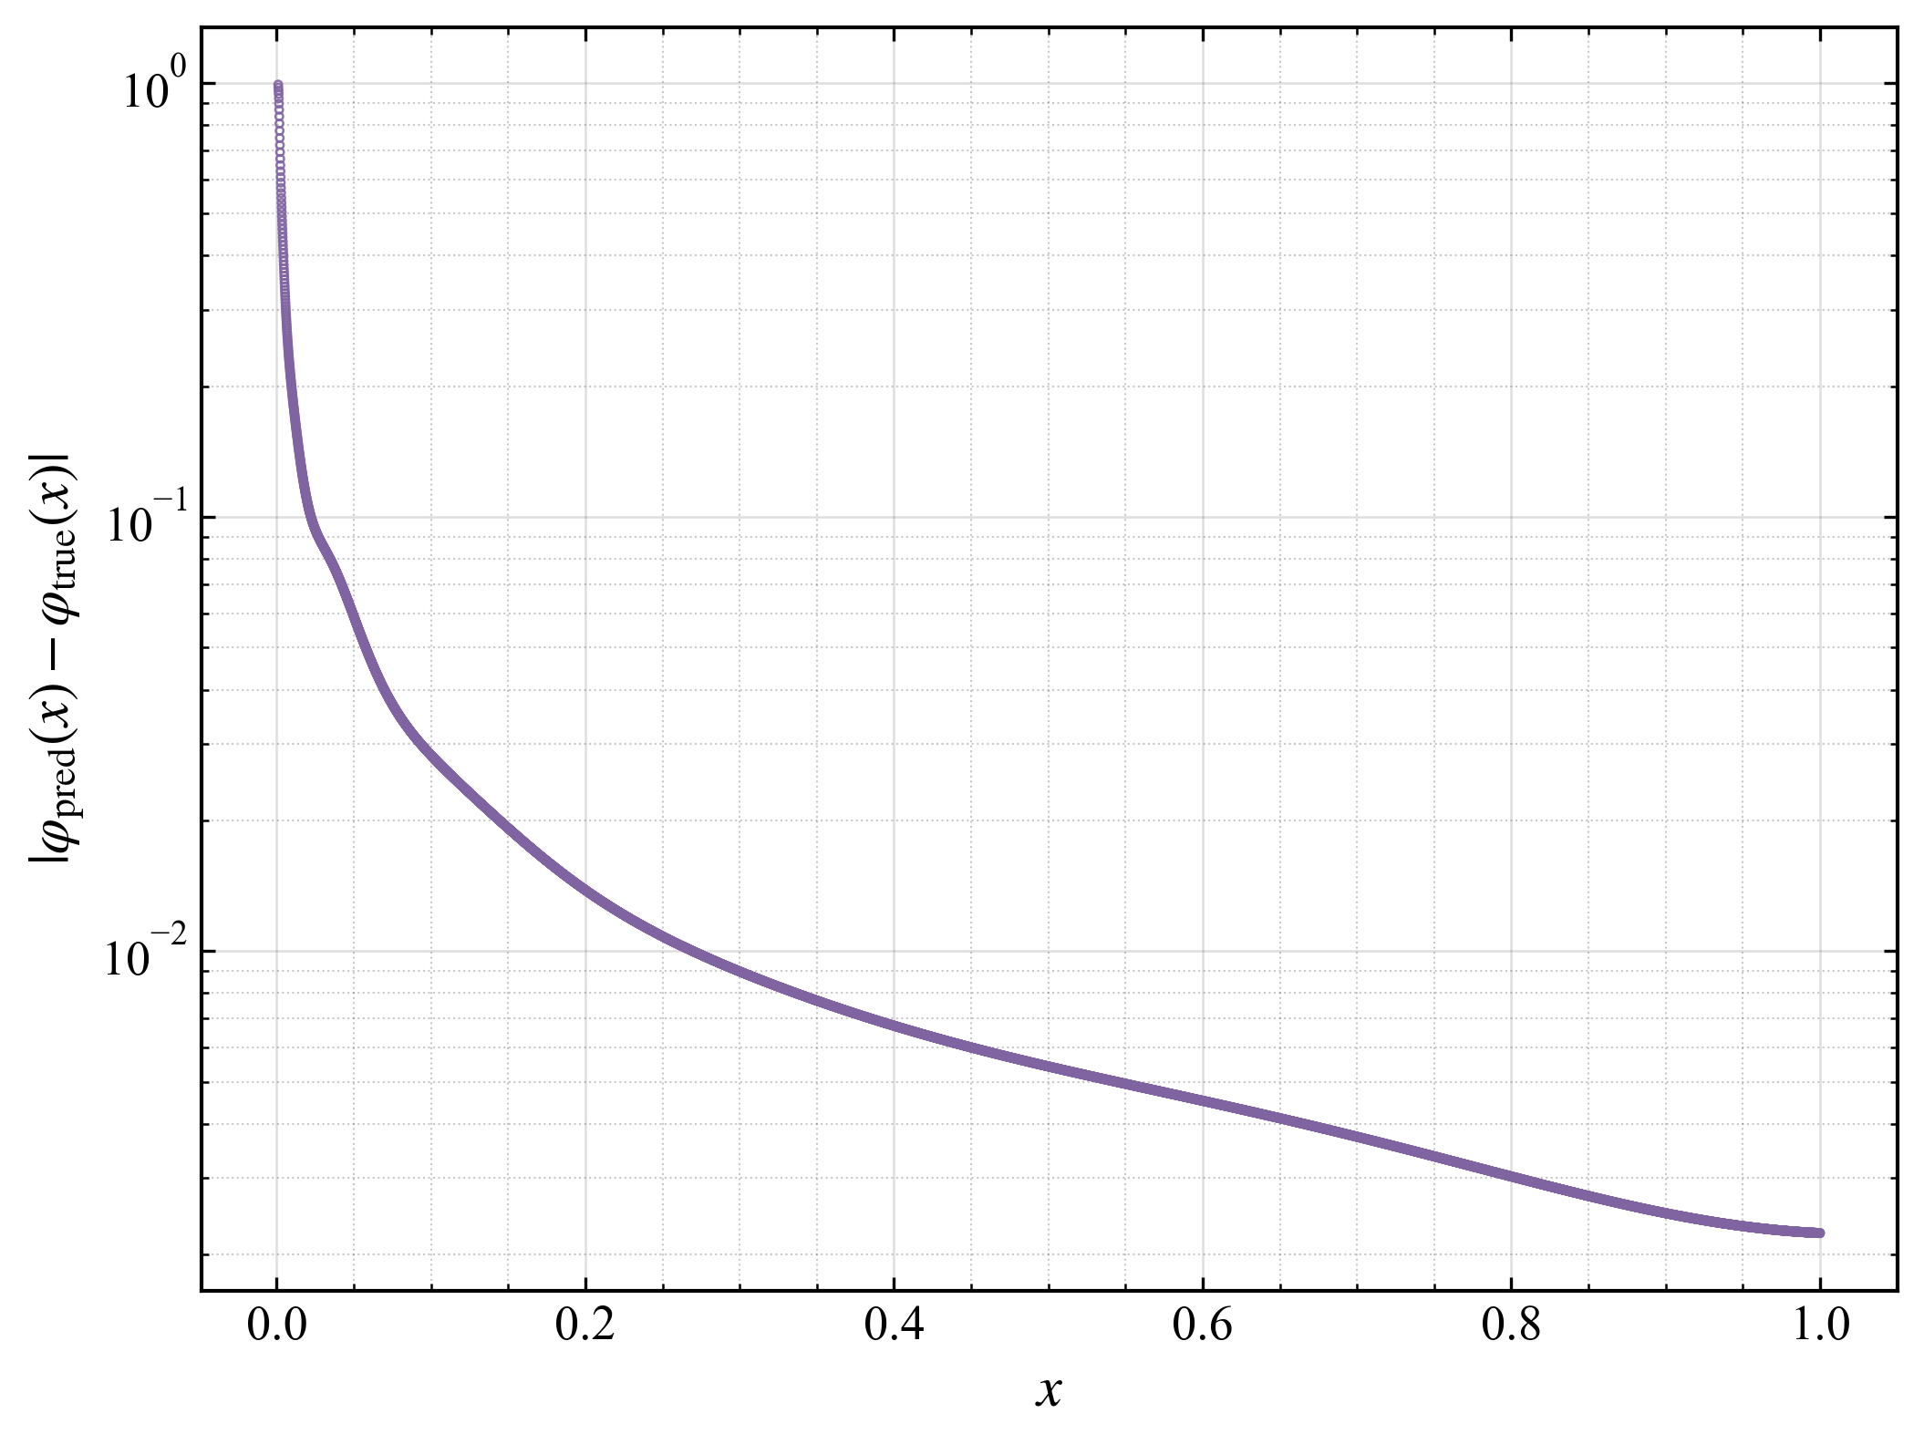 | 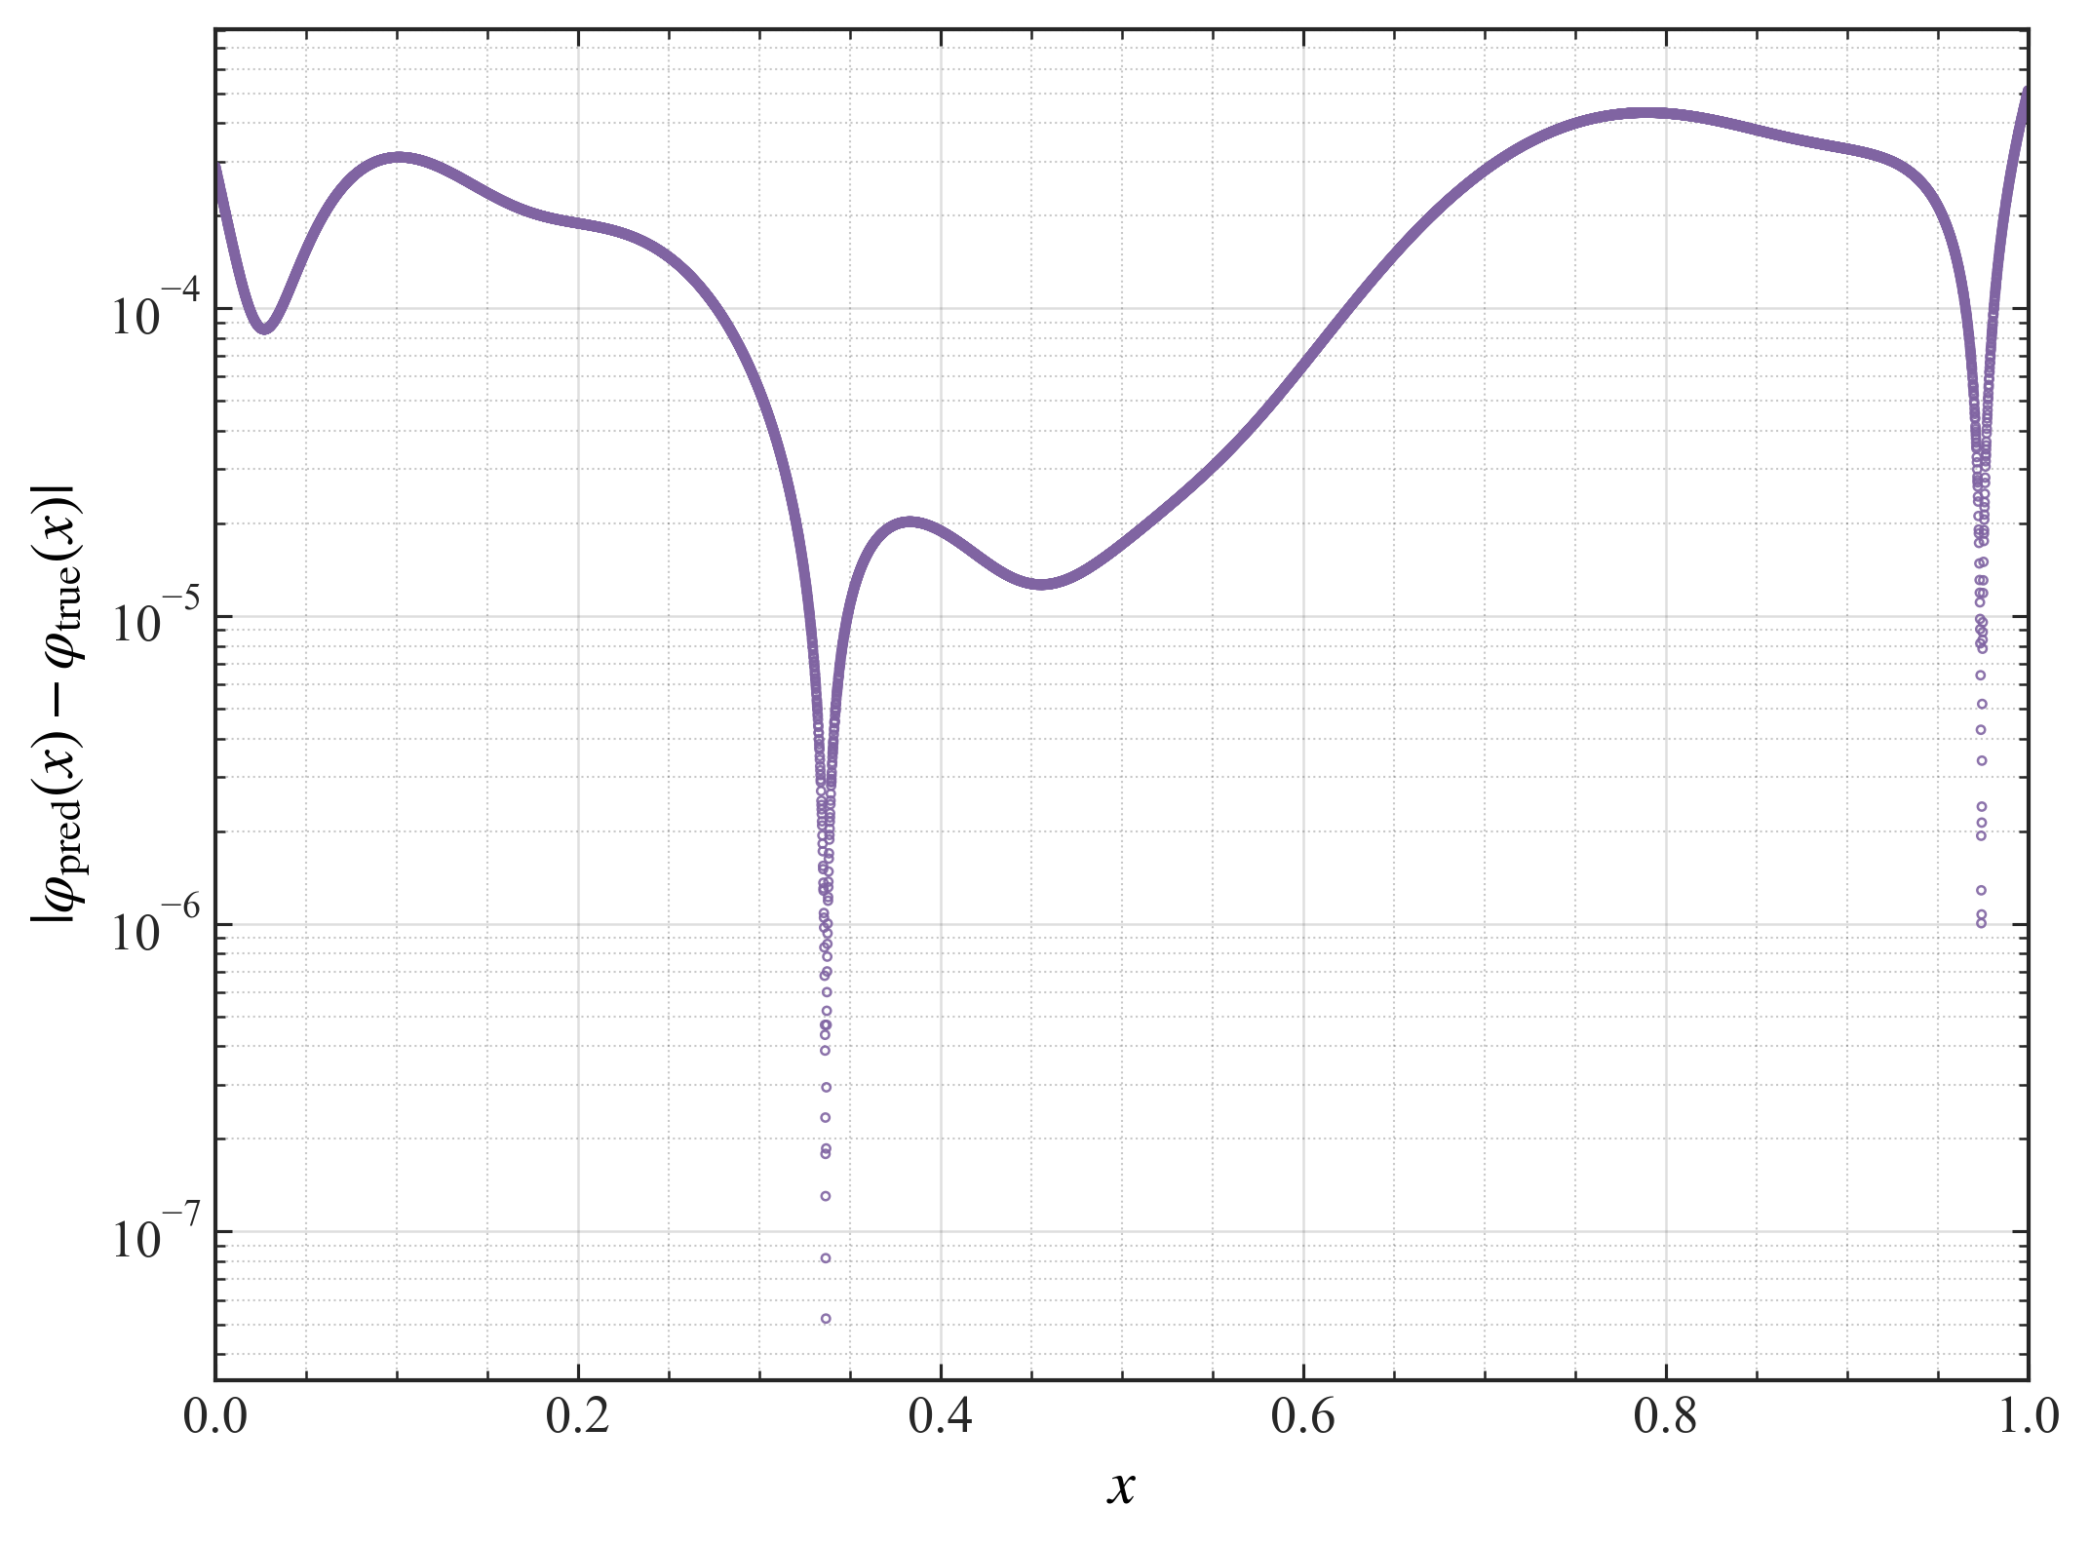 | 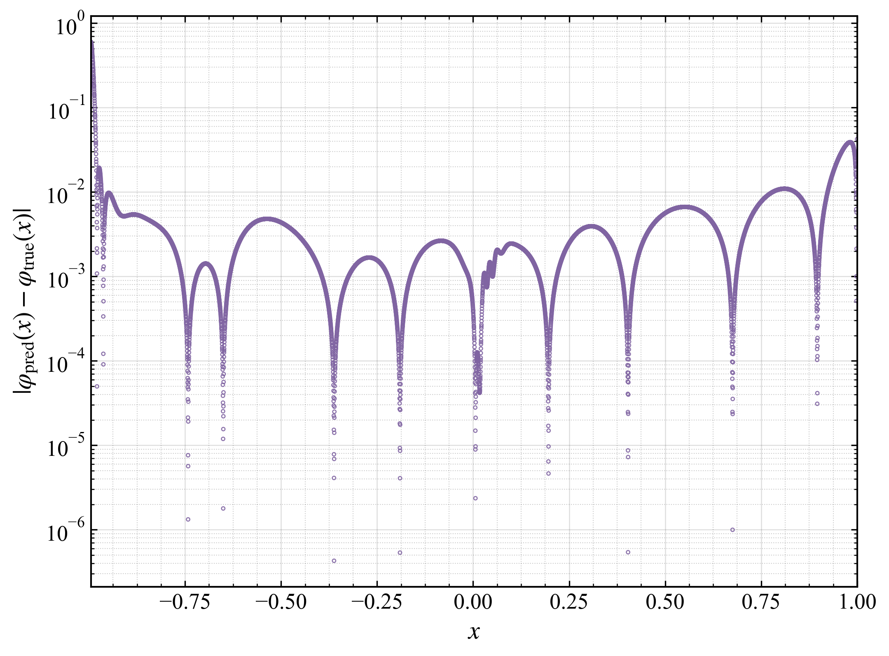
Fig. 4(c). Pointwise absolute-error distribution | Fig. 5(c). Pointwise absolute-error distribution | Fig. 10(c). Pointwise absolute-error distribution
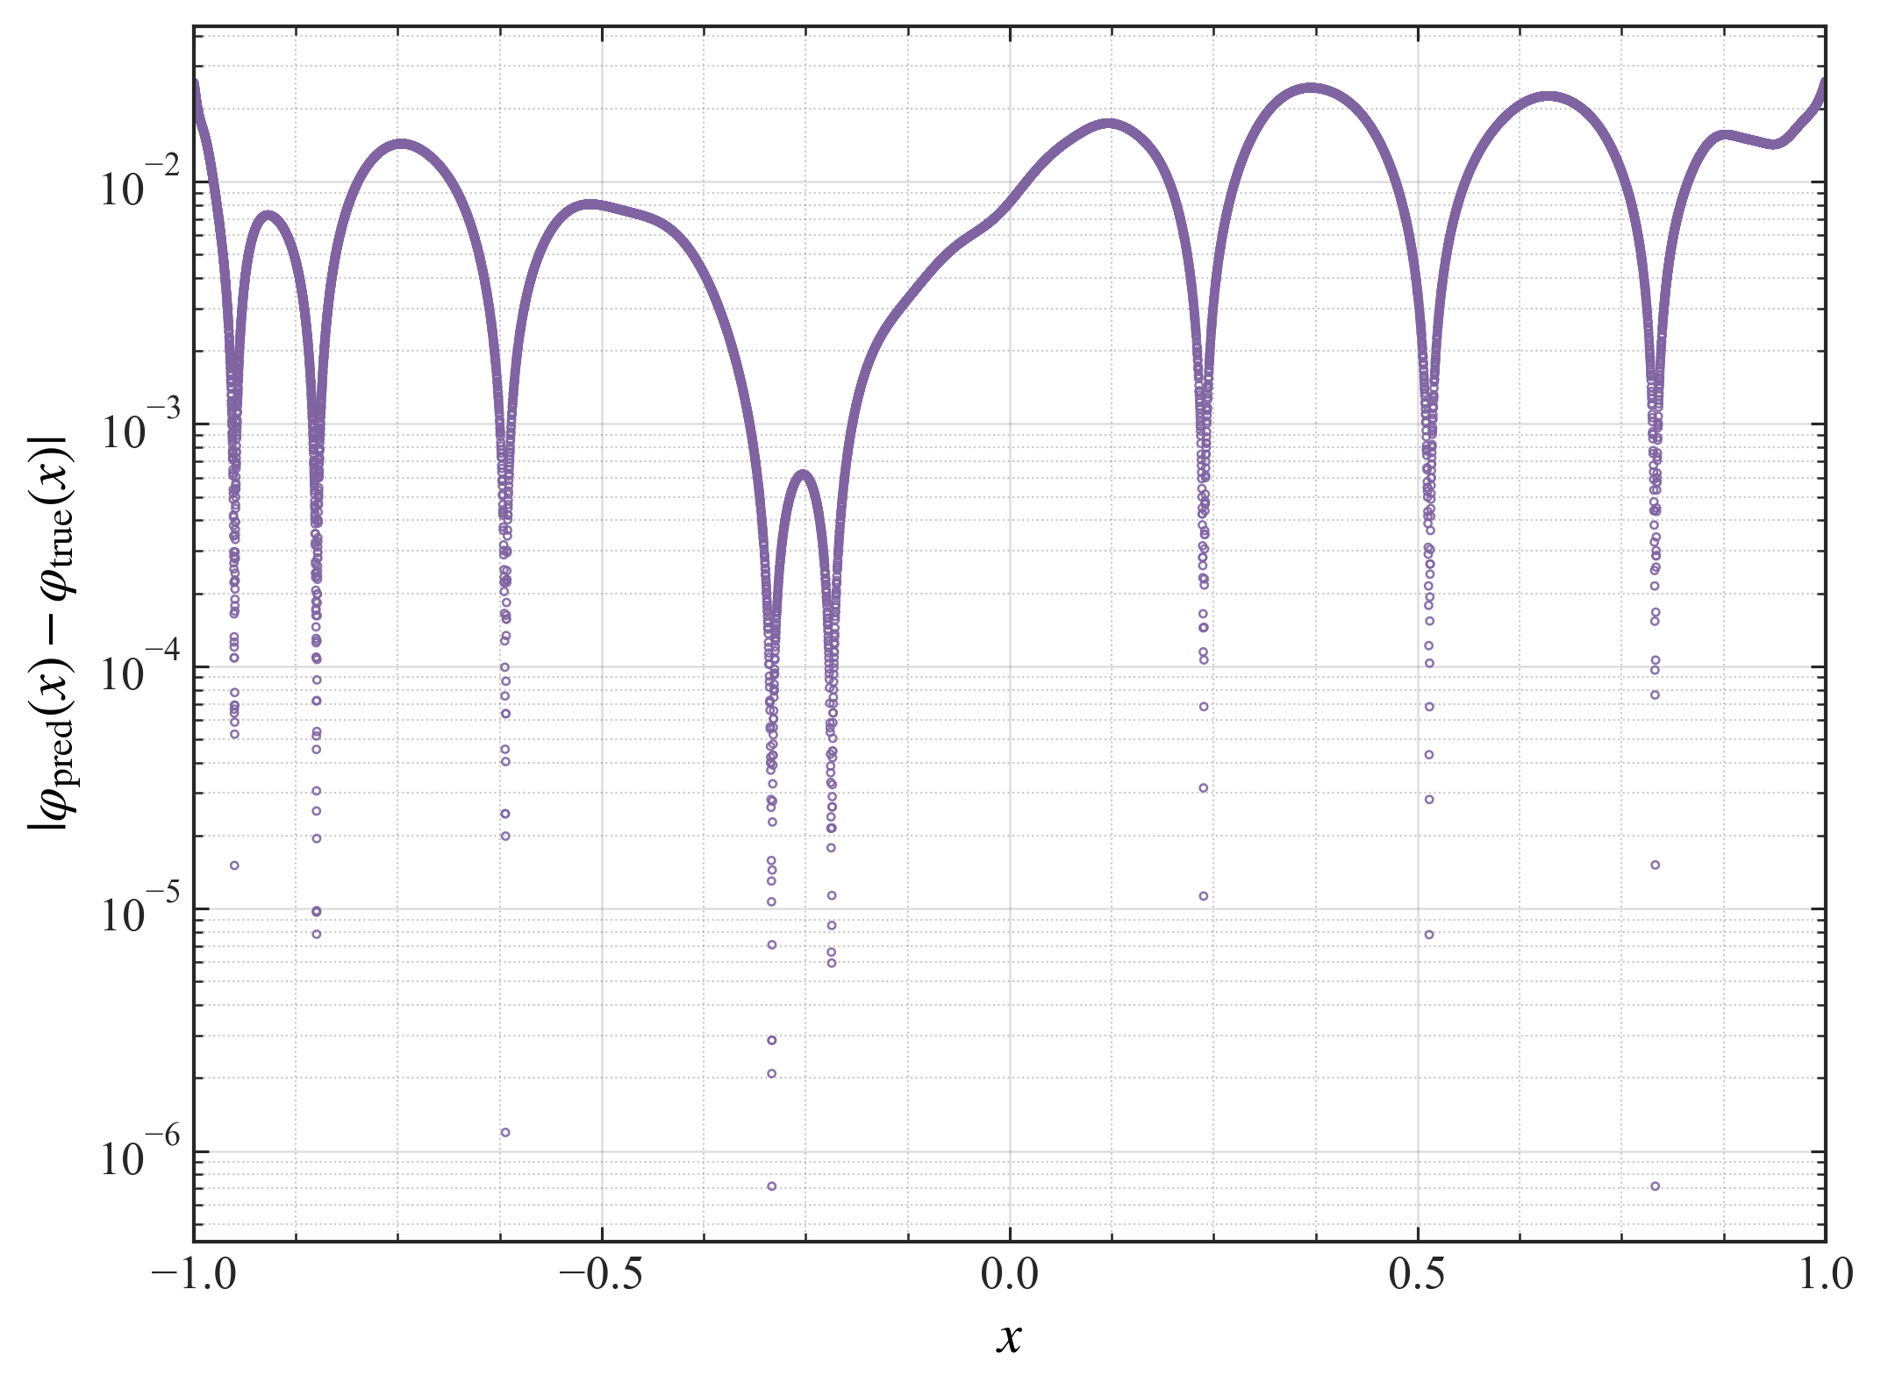 | 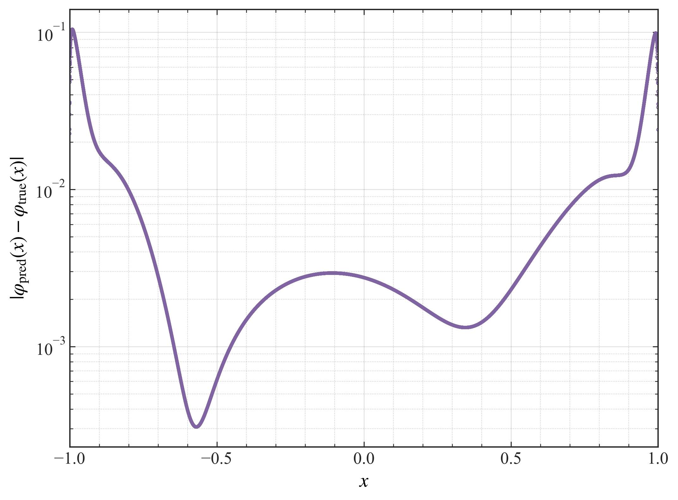
Fig. 11(c). Pointwise absolute-error distribution | Fig. 12(c). Pointwise absolute-error distribution

10. Write all references in a consistent format. For example, in References 4 and 16, ”pp.” is written before the page numbers, whereas in the other references it is not.
Response:
>> We thank the reviewer for these comments. We have removed the “pp.” prefix from Refs. [4] and [16] and standardized the formatting of the remaining references. The corresponding changes appear on page 20 (lines 414–416) and page 21 (lines 446–447).

11. Moreover, there are some minor grammatical inconsistencies throughout the manuscript which need to be corrected.
Response:
>> We thank the reviewer for these comments. We have carefully proofread and revised the grammar and language throughout the manuscript. Some representative examples of the revisions are given below:
"thus establishes new technical approaches" has been revised to "thus establishing new technical approaches" (see page 1, line 23).
"differential equations systems" has been revised to "differential equation systems" (see page 2, line 63).
All other grammatical and linguistic revisions have been marked in red in the revised manuscript.

Response to Reviewer #2:

1. Lack of theoretical analysis. The manuscript does not provide rigorous results regarding:
• Equivalence between the original singular integral equation and the transformed differential system;
• Stability of the proposed transformation;
• Convergence of the iterative neural-network procedure;
• Influence of the parameter ε introduced near singular points.
Response:
>> We thank the reviewer for these comments.
Regarding the equivalence and stability of the transformation from the original singular integral equation to the differential system, we have added the following statement:
“By the Newton–Leibniz formula, if the kernel in an integral term is continuous over the solution domain, then, provided that a definite solution exists, the integral term and its antiderivative are in one-to-one correspondence. This establishes the equivalence between the original singular integral equation and the transformed differential system [1,28]. Because the antiderivative transformation of an integral term with a continuous kernel is mathematically rigorous, the transformation is stable.”
See Refs. [1,28] and the derivation in the main text, page 4, lines 127–131, Eqs. (9)–(11).
The convergence of neural-network iterative solvers for differential equations is a central research topic in scientific machine learning, and current studies in this field verify convergence mainly through numerical experiments. We have therefore added the following statement in Section 6.2:
“The experimental results show that the total loss of the proposed method decreases progressively with the iterations and then levels off, indicating that the computational process exhibits good convergence, as shown in Fig. 6.” See page 14, lines 320–322.
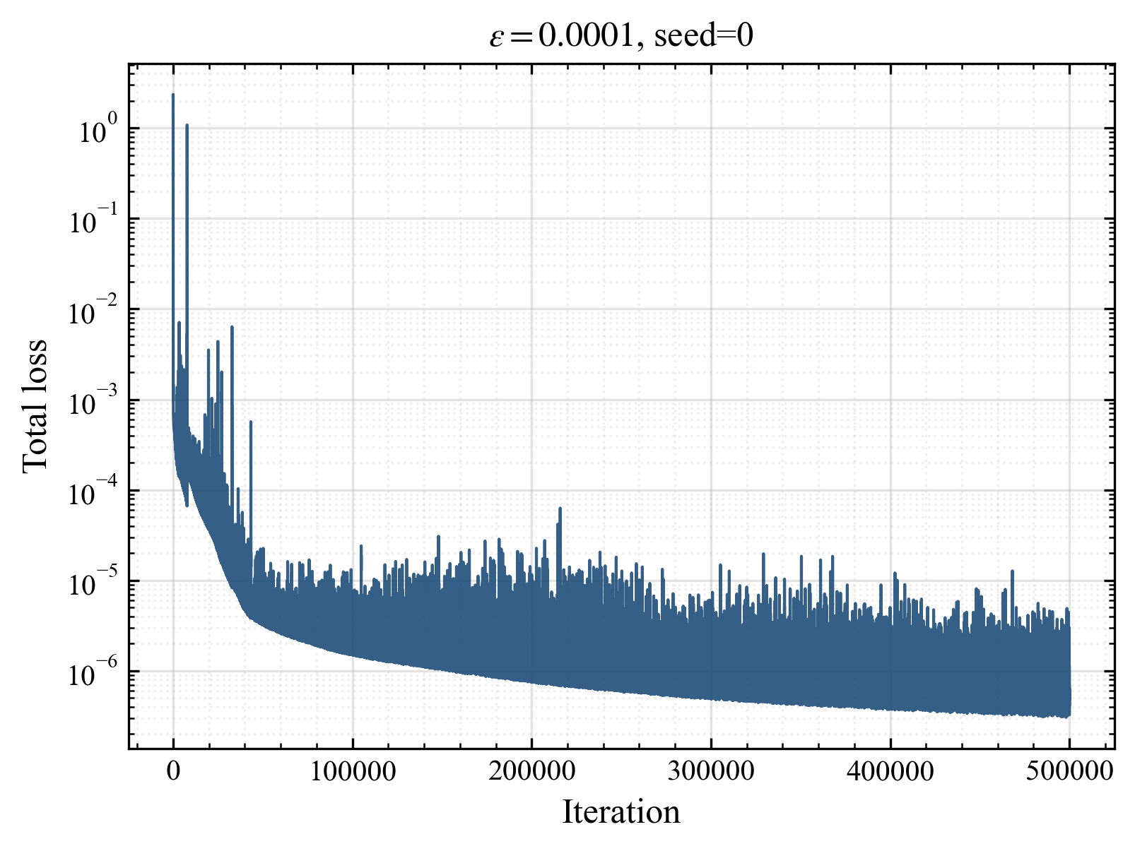
Fig. 6. Evolution of the total loss
To assess the influence of the parameter ε introduced near the singular point, we carried out a systematic sensitivity analysis in Section 6.2 and added the following statement:
“Eleven values of 𝜀 were selected across different orders of magnitude, and five independent repeated runs were carried out for each value. Fig. 7 shows the variation of the MSE with 𝜀, together with the error bars obtained from the repeated runs. The results show that for ε > 0.001 the prediction error decreases as ε decreases, whereas for ε < 0.001 the prediction error remains essentially unchanged.” See page 13, lines 312–314, and page 14, lines 318–320.

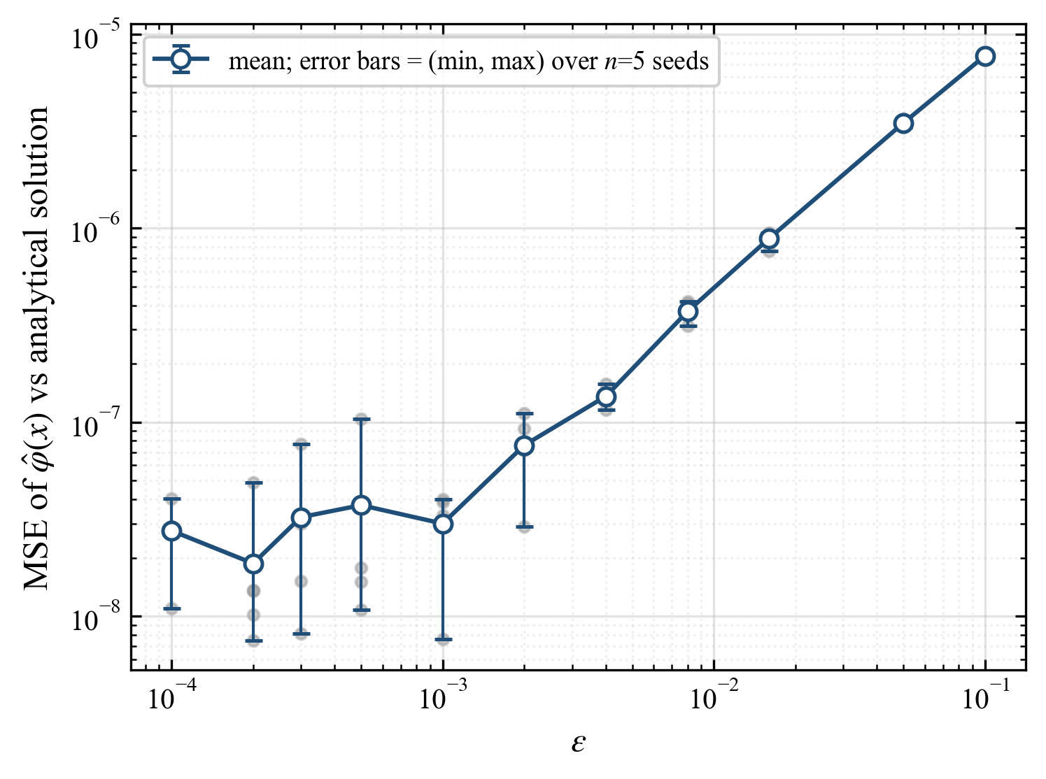
Fig. 7. Mean squared error of the predicted solution as a function of ε

2. Insufficient comparison with existing methods. The effectiveness of D-AIM is demonstrated only through benchmark examples. Comparisons with established numerical methods, such as collocation methods, spectral methods, boundary element techniques, or existing PINN-based approaches, are missing.
Response:
>> We thank the reviewer for these comments. Because D-AIM is a deep-learning method, we chose to compare it with the conventional PINN method. We have added the corresponding comparison to Section 6.2, with the main results summarized as follows:
“Fig. 8 shows the evolution of the total loss with the number of training epochs for the PINN method, and Fig. 9 compares the D-AIM solution, the PINN solution, and the analytical solution. The results show that the loss of the PINN method oscillates drastically during training and does not decrease to a converged level, resulting in a large error; the D-AIM method therefore exhibits a clear performance advantage over the conventional PINN in this example.”
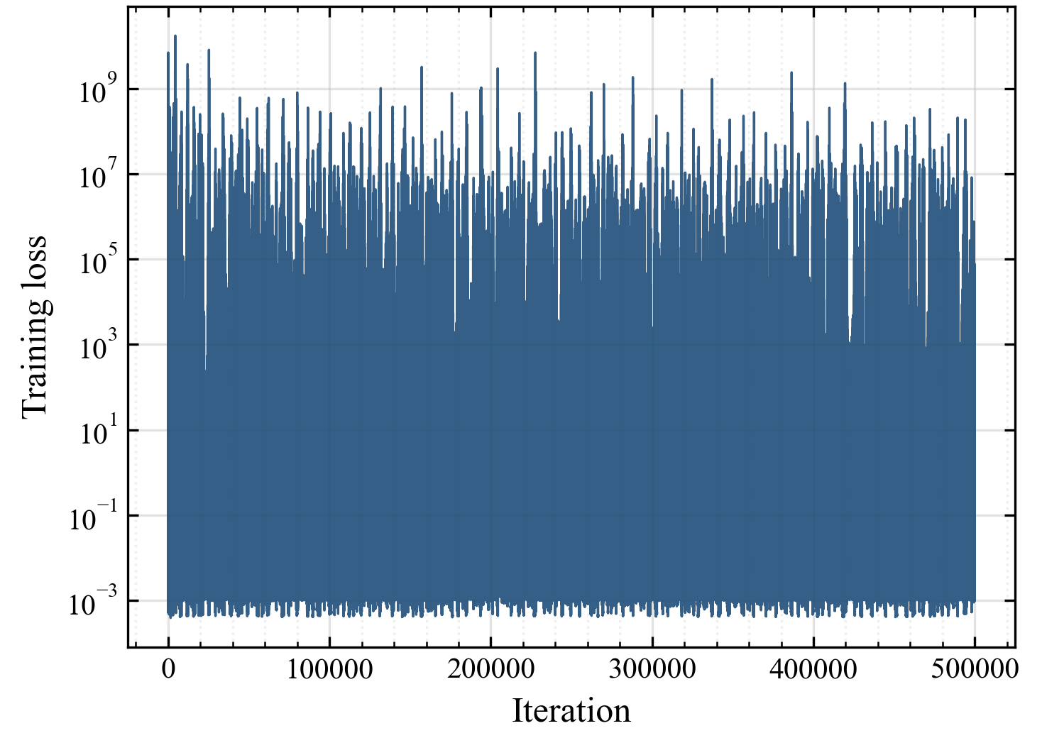 | 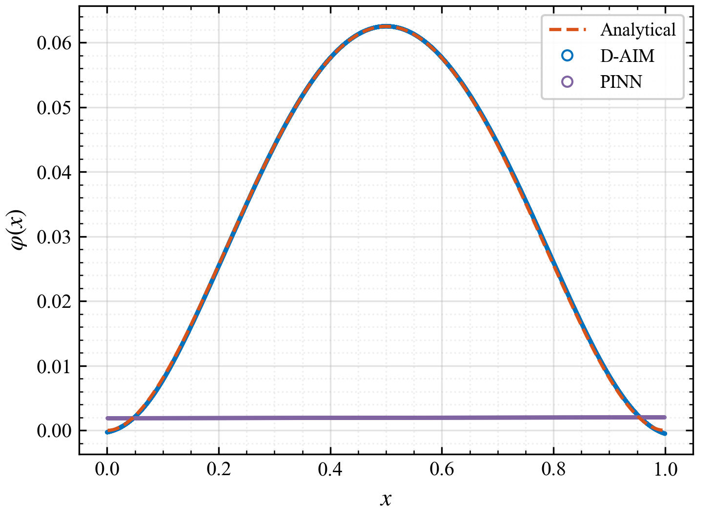
Fig. 8. Evolution of the total loss | Fig. 9. Comparison of the predicted solutions with the analytical solution
The corresponding changes appear on page 14 (lines 324–328).

3. Sensitivity to hyperparameters. The network architecture, loss weights, sampling strategy, and values of ε appear to be selected empirically. A sensitivity study would significantly strengthen the manuscript.
Response:
>> We thank the reviewer for these comments.
We have carried out a systematic sensitivity analysis of ε in Section 6.2 and added the following statement:
“Eleven values of 𝜀 were selected across different orders of magnitude, and five independent repeated runs were carried out for each value. Fig. 7 shows the variation of the MSE with 𝜀, together with the error bars obtained from the repeated runs. The results show that for ε > 0.001 the prediction error decreases as ε decreases, whereas for ε < 0.001 the prediction error remains essentially unchanged.” See page 13, lines 312–314, and page 14, lines 318–320.

Fig. 7. Mean squared error of the predicted solution as a function of ε
With reference to existing research on deep learning based PDE solvers, hyperparameters such as the network architecture, sampling strategy, and loss weights still lack a well-established theoretical foundation, and are mainly determined empirically and through experiments. We therefore followed established PINN practice and selected the hyperparameters in our numerical experiments. A theoretical study of hyperparameter selection will be pursued in future work. We added the following sentence to the outlook in Section 7:
“Future research will focus on theoretically analyzing the convergence and stability of the multi-network iterative deep learning method and quantitatively evaluating its time and space complexity. Further theoretical studies will also examine how key hyperparameters, including network architecture, loss weights, and sampling strategies, affect solver performance.”
The corresponding changes appear on page 18-19 (lines 390–393).

4. Computational efficiency. Training time, hardware specifications, convergence history, and computational complexity are not discussed. These aspects are important when assessing the practical usefulness of deep learning-based numerical methods.
Response:
>> We thank the reviewer for these comments.
We have added the following description of the hardware configuration to Section 6:
“In this section, all numerical examples were trained on a single NVIDIA GeForce RTX 4070 Ti GPU. The networks were implemented, differentiated automatically and trained using PyTorch 2.12.0 with CUDA 12.6 acceleration, and the complete workflow was run in Python 3.13.”
The corresponding change appears on page 10 (lines 273–275).
We also added a discussion of training time and convergence history to Section 6.2, as follows:
“In the above computing environment, each training run took approximately 5400 s on average. Fig. 6 shows the evolution of the total loss with the number of training epochs. The loss decreases steadily and levels off at roughly 500,000 epochs, indicating that training has converged.” The corresponding change appears on pages 13-14 (lines 314–317).


Fig. 6. Evolution of the total loss
Regarding computational complexity, since the quantitative analysis of the complexity of deep learning is a recognized challenge in the field, we will pursue this issue in our future research. We have added the following clarification to the outlook section:
“Future research will focus on theoretically analyzing the convergence and stability of the multi-network iterative deep learning method and quantitatively evaluating its time and space complexity.”
The corresponding change appears on page 18 (lines 390–391).

5. The literature review should better position the proposed method with respect to PINNs, XPINNs, BINNs, DeepONets, and neural operator frameworks.
Response:
>> We thank the reviewer for these comments. We have expanded the literature review in Section 1 to clarify how the proposed method relates to these five classes of methods, as follows:
“In recent years, deep learning has been used not only for differential equations [19-23] but also increasingly for integral equations. PINN-based methods have been developed for multidimensional Fredholm integral equations [24,25], volume integral equations [26], boundary integral equations [27] and other multidimensional integral equations with continuous kernels [28]. For integral equations with discontinuous coefficients, domain-decomposed XPINNs are often used to accommodate non-smooth solutions across interfaces [29]. DeepONet and neural-operator methods are suitable for solving a class of parameterized problems [21,30-32], thereby enhancing the generalization capability of deep learning based numerical computation. Most of these studies concern non-singular integral equations and evaluate the integral terms by numerical integration, which introduces additional discretization error. The boundary integral neural network (BINN) is an important exception: it converts a PDE into a boundary integral equation using a Green’s function and evaluates weakly singular and Cauchy-type singular integrals by regularization techniques. Its applicability, however, depends on the existence of the BIE formulation and the fundamental solution. In many non-linear problems, the unknowns in the interior region cannot be completely eliminated. Moreover, the fundamental solution may be hard to obtain or even not exist [27]. Therefore, it is necessary to explore new deep learning methods for solving singular integral equations.”
The corresponding change appears on page 2 (lines 42–57).

6. Several grammatical and stylistic issues remain and careful proofreading is recommended.
Response:
>> We thank the reviewer for these comments. We have carefully proofread and revised the grammar and language throughout the manuscript. Some representative examples of the revisions are given below:
"thus establishes new technical approaches" has been revised to "thus establishing new technical approaches" (see page 1, line 23).
"differential equations systems" has been revised to "differential equation systems" (see page 2, line 63).
All other grammatical and linguistic revisions have been marked in red in the revised manuscript.

7. Error distributions and convergence plots would be more informative than solution plots alone.
Response:
>> We thank the reviewer for these comments. We have added a pointwise error-distribution plot for every example in Section 6, as shown below:
 |  | 
Fig. 4(c). Pointwise absolute-error distribution | Fig. 5(c). Pointwise absolute-error distribution | Fig. 10(c). Pointwise absolute-error distribution
 | 
Fig. 11(c). Pointwise absolute-error distribution | Fig. 12(c). Pointwise absolute-error distribution
The corresponding changes are shown in Section 6, Figs. 4, 5, 10, 11 and 12.
For the convergence curve, we added the following statement to Section 6.2:
“Fig. 6 shows the evolution of the total loss with the number of training epochs. The loss decreases steadily and levels off at roughly 500,000 epochs, indicating that training has converged.” The corresponding change appears on pages 13-14 (lines 315–317).


Fig. 6. Evolution of the total loss

8. A schematic workflow illustrating the D-AIM procedure would improve readability.
Response:
>> We thank the reviewer for these comments. We revised the relevant text in Section 5 and the figure caption so that Fig. 3 explains each step of the D-AIM workflow more clearly:
“After transforming the integral equations into exact differential equations and defining the corresponding loss functions, the deep learning process can be carried out either with the standard PINN framework[19] or with one of the improved deep-learning architectures developed for differential equations[27,29,35]. The deep learning process involves setting the network structures of neural network functions , and , constructing machine learning sample sets according to their respective solution domains, and updating the weights and biases in equation according to the weighted loss functions determined by equations and , so that , and decrease alternately and gradually approach zero. In the training process described above, the number of loop iterations in the computational procedure depends on the complexity of the task. Once training is complete, approximates the numerical solution of the equation. In practice, convergence criteria are generally set for loss functions, i.e., less than the preset minimum value , or a maximum number of machine learning rounds. Machine learning stops when convergence criteria are satisfied. Taking the case where all neural network loss functions are less than as the convergence criterion, the iterative computation flowchart is shown in Fig. 3:”
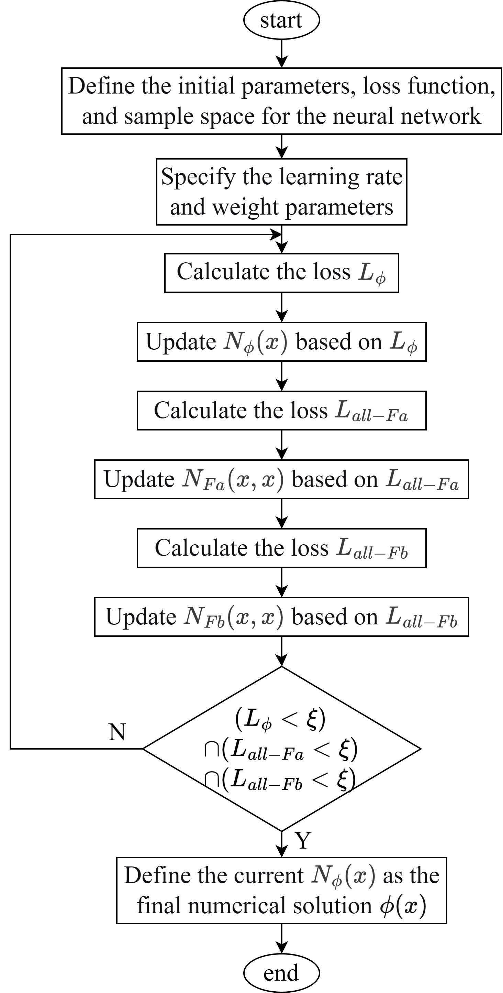
Fig. 3 Workflow of the D-AIM procedure
The corresponding changes appear on page 10 (lines 256–271).

9. A table summarizing the notation would help readers follow the derivations.
Response:
>> We thank the reviewer for these comments. We have added a notation table (Table 3) summarizing the symbols used in the manuscript. It is included as an appendix at the end of the manuscript. The corresponding change appears on page 19 (lines 399–401).

Table 3. Symbols and definitions
Symbol | Definition
a, b | Lower and upper limits of integration
x, t | Independent and integration variables, x, t ∈ [a, b]
ϕ(x) | Unknown solution of the singular integral equation
λ | Fixed parameter of the integral equation
a(x), f(x) | Known functions
K(x, t) | Singular integral kernel
G(x, t) | Continuous and bounded part of the kernel
α | Order of the kernel singularity
ε | Small quantity
Ω | Integration domain
F(x, t) | Antiderivative of the integral term
C | Constant
 | Neural-network input vector
 | Neural-network weights and biases
 | Network depth
 | Number of hidden neurons
 | Neural-network output for ϕ(x)
 | Neural-network output for F_{a} (x, t), F_{b} (x, t)
 | Loss function for the original governing equation
 | Loss function for the antiderivative equation
 | Loss function for the antiderivative definite solution constraint
 | Unified machine-learning loss for the antiderivative
 | Loss-function weights
 | Convergence tolerance for the training loss
 | Mean squared error

[1] F.G. Tricomi, Integral Equations, Dover Publications, New York, 1985.
[19] M. Raissi, P. Perdikaris, G.E. Karniadakis, Physics-informed neural networks: A deep learning framework for solving forward and inverse problems involving nonlinear partial differential equations, J. Comput. Phys. 378 (2019) 686–707. https://doi.org/10.1016/j.jcp.2018.10.045.
[20] G.E. Karniadakis, I.G. Kevrekidis, L. Lu, P. Perdikaris, S. Wang, L. Yang, Physics-informed machine learning, Nat. Rev. Phys. 3 (2021) 422–440. https://doi.org/10.1038/s42254-021-00314-5.
[21] E. Zappala, A.H. de O. Fonseca, J.O. Caro, A.H. Moberly, M.J. Higley, J. Cardin, D. van Dijk, Learning integral operators via neural integral equations, Nat. Mach. Intell. 6 (2024) 1046–1062. https://doi.org/10.1038/s42256-024-00886-8.
[22] S. Cuomo, V.S. Di Cola, F. Giampaolo, G. Rozza, M. Raissi, F. Piccialli, Scientific machine learning through physics–informed neural networks: where we are and what’s next, J. Sci. Comput. 92 (2022) 88. https://doi.org/10.1007/s10915-022-01939-z.
[23] S.L. Brunton, J.N. Kutz, Promising directions of machine learning for partial differential equations, Nat. Comput. Sci. 4 (2024) 483–494. https://doi.org/10.1038/s43588-024-00643-2.
[24] Y. Guan, T. Fang, D. Zhang, C. Jin, Solving fredholm integral equations using deep learning, Int. J. Appl. Comput. Math. 8 (2022) 87. https://doi.org/10.1007/s40819-022-01288-3.
[25] Y. Ma, W. Li, Efficient solution of second-kind Fredholm integral equations using L1 space discrete coordinates and physics-informed neural networks, Next Res. 2 (2025) 100534. https://doi.org/10.1016/j.nexres.2025.100534.
[26] R. Guo, T. Shan, X. Song, M. Li, F. Yang, S. Xu, A. Abubakar, Physics embedded deep neural network for solving volume integral equation: 2-D case, IEEE Trans. Antennas Propag. 70 (2022) 6135–6147. https://doi.org/10.1109/TAP.2021.3070152.
[27] J. Sun, Y. Liu, Y. Wang, Z. Yao, X. Zheng, BINN: A deep learning approach for computational mechanics problems based on boundary integral equations, Comput. Methods Appl. Mech. Eng. 410 (2023) 116012. https://doi.org/10.1016/j.cma.2023.116012.
[28] D. Liu, Y. Liu, H. Dang, K. Wang, B. Zhang, F. Wang, Z. Liu, Y. Jiang, The neutron transport equation in exact differential form, Sci. China Phys. Mech. Astron. 68 (2025) 270511. https://doi.org/10.1007/s11433-024-2642-3.
[29] A.D. Jagtap, G.E. Karniadakis, Extended physics-informed neural networks (XPINNs): A generalized space-time domain decomposition based deep learning framework for nonlinear partial differential equations, Commun. Comput. Phys. 28 (2020) 2002–2041. https://doi.org/10.4208/cicp.oa-2020-0164.
[30] L. Lu, P. Jin, G. Pang, Z. Zhang, G.E. Karniadakis, Learning nonlinear operators via DeepONet based on the universal approximation theorem of operators, Nat. Mach. Intell. 3 (2021) 218–229.
[31] Z. Li, N. Kovachki, K. Azizzadenesheli, B. Liu, K. Bhattacharya, A. Stuart, A. Anandkumar, Fourier neural operator for parametric partial differential equations, in: International Conference on Learning Representations, 2021.
[32] N. Kovachki, Z. Li, B. Liu, K. Azizzadenesheli, K. Bhattacharya, A. Stuart, A. Anandkumar, Neural operator: Learning maps between function spaces, arXiv:2108.08481, 2021.

